OOPS ASSIGNMENT 2

Name: Shravan Sapate Roll NO :27
UID:23016027 CSBS (2ND Year) Date:1-OCT-2024

Case Study: Exception and Error Handling in C++
Overview: Exception handling in C++ is a mechanism to manage runtime errors, ensuring the normal flow of a program without crashing. Errors can occur due to invalid user inputs, hardware failures, or unexpected behaviour during execution. C++ offers the try, throw, and catch constructs to handle these situations gracefully.
Information:
1. Exception Handling: This refers to the process of dealing with exceptional situations in a controlled manner using try, throw, and catch.
2. Error Handling: Detecting and recovering from errors such as logic errors or invalid data inputs. Often, return codes are used alongside exceptions to report errors.
In C++, exception handling is a way to manage errors and unexpected events that occur during the execution of a program. It allows a program to continue functioning or terminate gracefully without crashing. The three key constructs in exception handling are try, throw, and catch.
- try Block The try block contains the code that might generate an exception. It is where you "try" to execute code that could potentially cause an error or exception. When an error occurs within a try block, the control is transferred to the corresponding catch block.
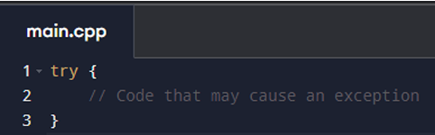

2. throw Statement The throw statement is used to "throw" an exception when an error condition arises. This can be any type of exception—built-in types like integers, floating-point numbers, or user-defined exceptions (like classes). Once an exception is thrown, the program immediately leaves the try block and searches for the corresponding catch block that can handle the exception.

3. catch Block The catch block is used to "catch" the exception that was thrown and handle it. Multiple catch blocks can be used to handle different types of exceptions. If no matching catch block is found, the program will terminate.

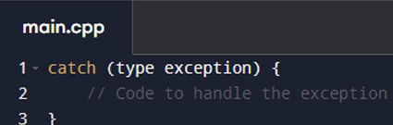

Example of try, throw, and catch keywords:
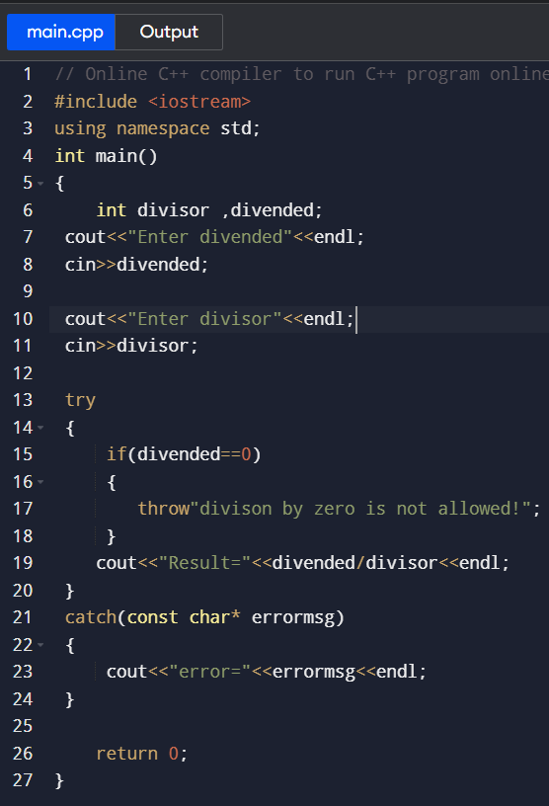

OUTPUTS:
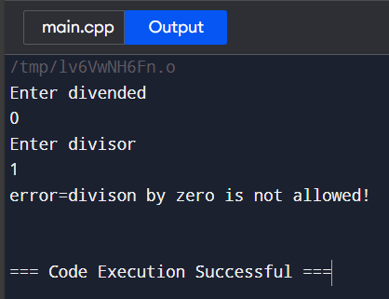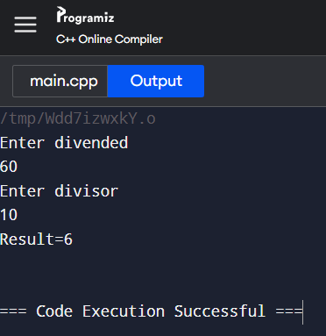
Code_2: Handling Division by Zero

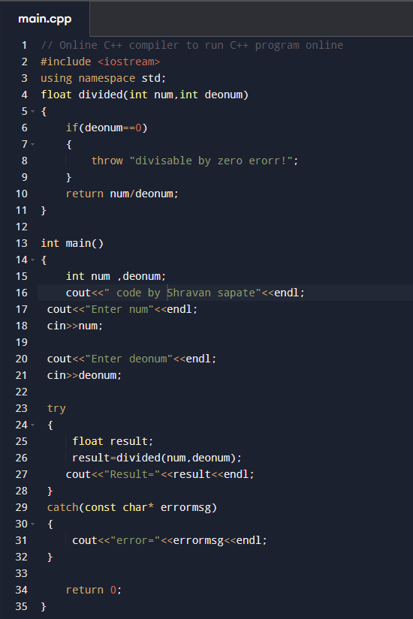

Output:

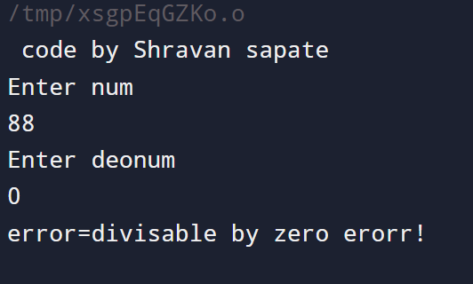
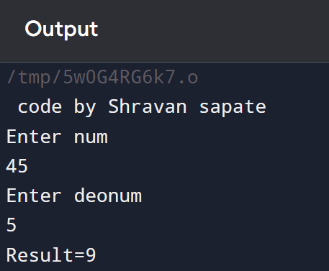

Code_3: Handling Multiple Exceptions
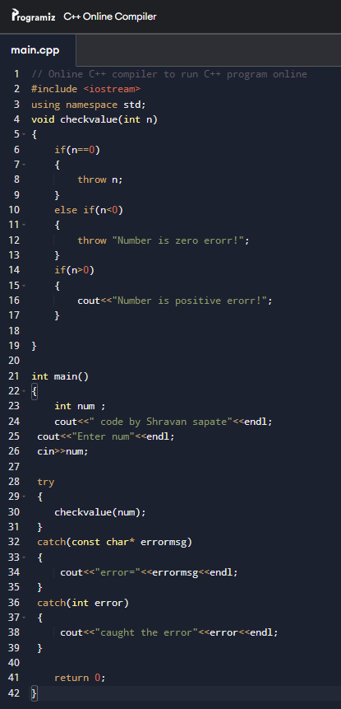

OUTPUT

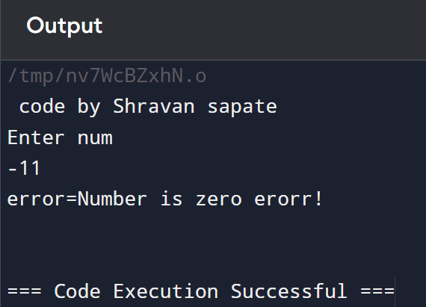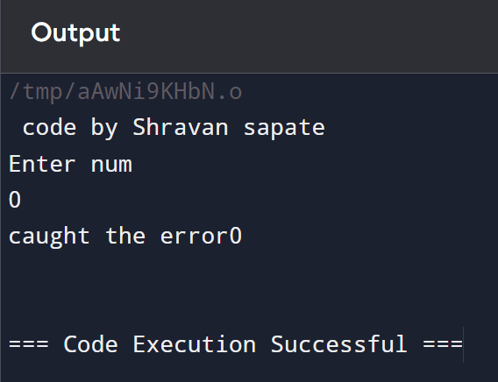

Summary:
• Exception handling in C++ allows programs to handle errors gracefully using the try, throw, and catch blocks.
• The first code handles insufficient balance in a banking system.
• The second code checks for division by zero.
• The third code demonstrates multiple exceptions for different error conditions.

